September, 2014

*Draft*

**VACCINE LOGISTICS**

**MANAGEMENT INFORMATION SYSTEM**

Administrator Manual





**Table of Contents**

[Revision History 6](#_Toc400919064)

[List of Acronyms 7](#_Toc400919065)

[Overview 9](#_Toc400919066)

[Background 10](#_Toc400919067)

[Overview 11](#_Toc400919068)

[Assumptions 13](#_Toc400919069)

[System Requirements 13](#_Toc400919070)

[Browser Support 13](#_Toc400919071)

[Administrator Roles 15](#_Toc400919072)

[Administrator Roles 15](#_Toc400919073)

[CCEM Administrator 16](#_Toc400919074)

[Super Administrator 17](#_Toc400919075)

[General Administrator 18](#_Toc400919076)

[CCEM Administrator 19](#_Toc400919077)

[vLMIS Homepage 20](#_Toc400919078)

[Homepage Menu 21](#_Toc400919079)

[Contact Us Tab 21](#_Toc400919080)

[Frequently Asked Questions Tab 21](#_Toc400919081)

[Logging into Vaccine Logistics Management Information System 22](#_Toc400919082)

[Changing Your Password 24](#_Toc400919083)

[Forgot Password 25](#_Toc400919084)

[Logging Out 26](#_Toc400919085)

[CCEM Administrator 27](#_Toc400919086)

[Manage Health Facility 29](#_Toc400919087)

[Manage Users 33](#_Toc400919088)

[Manage Lists 35](#_Toc400919089)

[Manage Asset Sub-types 38](#_Toc400919090)

[Manage Makes 40](#_Toc400919091)

[Manage Models 42](#_Toc400919092)

[Super Administrator 45](#_Toc400919093)

[Manage ACL 46](#_Toc400919094)

[Assign Role Resources 46](#_Toc400919095)

[Manage Resources 48](#_Toc400919096)

[Manage Roles 51](#_Toc400919097)

[Manage Stakeholders 53](#_Toc400919098)

[Stakeholders 53](#_Toc400919099)

[General Administrator 55](#_Toc400919100)

[General Administrator 55](#_Toc400919101)

[Manage Products 56](#_Toc400919102)

[Assign Role Resources 56](#_Toc400919103)

[Manage Resources 58](#_Toc400919104)

[Manage Roles 60](#_Toc400919105)

[Products 62](#_Toc400919106)

[Setup Barcode 64](#_Toc400919107)

[Item Categories 67](#_Toc400919108)

[Item Groups 69](#_Toc400919109)

[Manage Stakeholders 71](#_Toc400919110)

[Stakeholders 71](#_Toc400919111)

[Office 73](#_Toc400919112)

[Manufacturer 75](#_Toc400919113)

[Stakeholder Activities 78](#_Toc400919114)

[Stakeholder Types 80](#_Toc400919115)

[Stakeholder Sectors 82](#_Toc400919116)

[Stakeholder Items 84](#_Toc400919117)

[Manage Locations 85](#_Toc400919118)

[Add Locations 86](#_Toc400919119)

[Edit Locations 86](#_Toc400919120)

[Manage Stores/Facilities 87](#_Toc400919121)

[Routine 87](#_Toc400919122)

[Campaigns Teams 89](#_Toc400919123)

[Inventory 91](#_Toc400919124)

[Manage Users 93](#_Toc400919125)

[Routine Immunization 93](#_Toc400919126)

[Campaign Users 94](#_Toc400919127)

[IM Users 96](#_Toc400919128)

[Policy Users 98](#_Toc400919129)

# Revision History

|  |  |  |  |
| --- | --- | --- | --- |
| **Name** | **Date** | **Reason For Changes** | **Version** |
| Pakistan Field Office | August 2014 | First Draft | 1.0 |
| Pakistan Field Office | September 2014 | Additions to CCEM Admin | 1.1 |

# List of Acronyms

|  |  |
| --- | --- |
| CCEM | Cold Chain Equipment Manager |
| GOP | Government of Pakistan |
| HF | Health Facility |
| ICT | Information Communications Technologies |
| IT | Information Technology |
| JSI | John Snow, Inc. |
| LMIS | Logistics Management Information System |
| NPC | National |
| MIS | Management Information System |
| MNHRC | Ministry of National Health Services, Regulation and Coordination |
| MIPC | Ministry of Inter Provincial Coordination |
| SDP | Service Delivery Point |
| SOP | Standard Operating Procedure |
| UC | Union Council |
| UNICEF | United Nations Children's Fund |
| USAID | United States Agency for International Development |
| WHO | World Health Organization |

|  |  |
| --- | --- |
| Overview | **1** |
| With Vaccine Logistics Management Information System | |

The *Vaccine Logistics Management Information System Administrators Manual* provides step-by-step instructions that help administrative users to get started with Vaccine Logistics Management Information System (vLMIS) functions and features and provides guidelines on managing relevant Vaccines Logistics roles using the Vaccine Logistics Management Information System admin accounts.

|  |  |
| --- | --- |
| *C:\Users\isbah.zulfiqar\Desktop\1382615592_file_edit.png* | **Before You Begin...**  It is recommended to have a working internet connection for web-access to the application in order to review the product side-by-side when reading this manual. |

# Background

In July 2011, Pakistan’s first web-based Logistics Management Information System (web-LMIS) for contraceptive products was launched, which is currently in use in all 143 districts. Following the success of the Logistics Management Information System for Contraceptives, the design of a   
web-based Tuberculosis Drug Management Information System (TBDMIS) was rolled-out in   
March 2013 - and now, Vaccine Logistics Management Information System has also been incorporated into the current Logistics Management Information System in 54 priority districts in Pakistan, thus making the web-based Pakistan Logistics Management Information System as one automated logistics management information system for all health commodities, i.e., Contraceptives, Tuberculosis and Vaccines.

The Vaccine Logistics Management Information System (vLMIS) is designed to replace the current manual Vaccine Logistics Record keeping system and therefore considers the current system’s strengths and challenges.

Among the strengths in the current vaccine logistics data is that key data items are collected, such as consumption, stock balance, and storage capacity. Some logistics-related key performance indicators have been defined and are tracked. Data is collected routinely and there is a defined process flow for reporting up the system. There are established forms and spreadsheets used to collect data, and a vaccine stock management software solution used at the National EPI Store. There is a culture of compiling and analyzing data for logistics decision making. The data on existing cold chain equipment (age, type, capacity, operability) in the national cold chain inventory as well as facility profile data has also been collected to help identify gaps in the cold chain storage capacity and functionality that need to be addressed.

However, there are significant challenges in the collection, use and management of vaccine logistics data. Routine reporting of logistics data is impeded by poor accuracy and timeliness of the reports and inadequate supervision and feedback on reporting. Wastage (due to open vial) data are under-reported and poorly tracked. Resupply is calculated based on demographic based targets (using population figures that are outdated) rather than consumption data, and stock balance is not always factored into resupply decisions. Because data is not available in real-time electronic form to all stakeholders, there is very limited visibility in the pipeline below the national level.

# Overview

Pakistan Web-based LMIS provides transparency to all stakeholders based on user rights, is easy to use, and integrates both routine and special immunization campaign vaccine logistics data. Standardized reporting forms and Data triangulation is implemented to validate data and improve visibility in wastage rates.

Resupply quantities for routine EPI are calculated based on average monthly consumption and stock balances, and wastage rates are calculated automatically. The use of stock balance, consumption and issued data, losses and adjustments are also collected.

New routine reporting forms are aquatically printed using vLMIS inventory management module in order to collect data from service delivery points, along with vaccine logistics standard operating procedures (SOPs) for each level of the supply chain.

The Vaccine Logistics Management Information System contains the following features:

1. A module for Vaccine reporting in the centralized web-accessible data repository of LMIS to report data from data providers. Data Providers can perform monthly data entry. This also includes being able to generate reports for themselves.
2. The data provided by different geographical levels tracks vaccines in different data entry forms. The Stock Issue and Receive Data, (National, Provincial, Divisional, District, Tehsil) users will enter vaccines logistics data with batch and expiry information, while Monthly Consumption data (Tehsil and Union Council level) users will report data without batch. Wastage will be calculated automatically with the help of consumed and unused vial information.
3. The cold-chain inventory and use is tracked in vLMIS. This module is capable of entering new cold chain assets as well as its current operational status. Each month, along with other logistics data, users will update the operational status of their cold chain assets.
4. The Administrator will manage vLMIS and create all of the necessary data in order to assist users to continue to provide and review logistics data.
5. Data Reviewers can access vLMIS using the ‘guest’ user account and get reports about the country’s provinces and districts to help them in logistical decision-making regarding supply chain management in their assigned districts.

## Assumptions

This manual assumes that you already have Vaccine Logistics Management Information System administrative accounts as per your role. This manual also assumes that you are familiar with basic web-application account login procedures.

## System Requirements

The Vaccines Logistics Management Information System is accessible from any Desktop PC, Mac, or Linux computer with Internet access and a supported Web-browser.

## Browser Support

The following browsers and later versions fully support vLMIS standard view:

* Mozilla Firefox (Windows, Mac, Linux)
* Google Chrome (Windows, Mac, Linux)
* Netscape (Windows, Mac, Linux)
* Safari (Mac)
* Internet Explorer 9 and above (Windows)

|  |  |
| --- | --- |
| Administrator Roles | **2** |
| of Vaccines Logistics Management Information System | |

This section explains the administrator accounts and their roles in Vaccine Logistics Management Information System.

# Administrator Roles

The Vaccine Logistics Management Information System administrator roles are basically assigned to admin users to manage the cold-chain logistics and general administrative activities within the vLMIS. This includes managing users, their roles, health facilities, products as well as stakeholders.

## CCEM Administrator

The CCEM administrator can be a vLMIS user with the following capabilities:

|  |  |
| --- | --- |
| **Feature** | **Responsibilities** |
| **Manage Health Facilities** | Manage health facilities and its data within the vLMIS |
| **Manage Users** | Manage users and their roles within the vLMIS |
| **Manage Lists** | Manage lists of the assets available to CCEM operators within the vLMIS |
| **Manage Asset Sub-types** | Manage sub-types of the assets available to CCEM operators within the vLMIS |
| **Manage Makes** | Manage makes of the assets available to CCEM operators within the vLMIS |
| **Manage Models** | Manage models of the assets available to CCEM operators within the vLMIS |

## Super Administrator

The super administrator can be a vLMIS user with the following capabilities:

|  |  |
| --- | --- |
| **Feature** | **Responsibilities** |
| **Manage ACL** | Manage roles, resources and users within the vLMIS |
| **Manage Stakeholders** | Manage stakeholders and their activities within the vLMIS |

## General Administrator

The general administrator can be a vLMIS user with the following capabilities:

|  |  |
| --- | --- |
| **Feature** | **Responsibilities** |
| **Manage Products** | Manage products, barcodes, items categories, units and groups within the vLMIS |
| **Manage Stakeholders** | Manage stakeholders, their activities, types and sectors within the vLMIS |
| **Manage Locations** | Manage geographical locations within the vLMIS |
| **Manage Stores/Facilities** | Manage routine, campaign and inventory stores / facilities within the vLMIS |
| **Manage Users** | Manage routine immunization, campaign, inventory management and policy users within the vLMIS |
| **vLMIS Explorer** | View previously submitted Monthly Report data for the selected warehouse and the specified month and year. |

|  |  |
| --- | --- |
| Step-by-Step | **3** |
| Process to using Vaccines Logistics Management Information System | |

This section explains the step-by-step instructions on getting started with vLMIS as a cold-chain equipment management (CCEM) administrative. In this section, you will learn about:

1. The Vaccine Logistics Management Information System Dashboard for CCEM.
2. Logging Into Vaccine Logistics Management Information System.
3. How to managing activities as a CCEM administrative.
4. Logging out of Vaccine Logistics Management Information System.

# vLMIS Homepage

The Logistics Management Information System has a single landing page for its three modules for Contraceptives, TB, and Vaccines Management Information System. Enter the URL <http://lmis.gov.pk> to access the application homepage.

**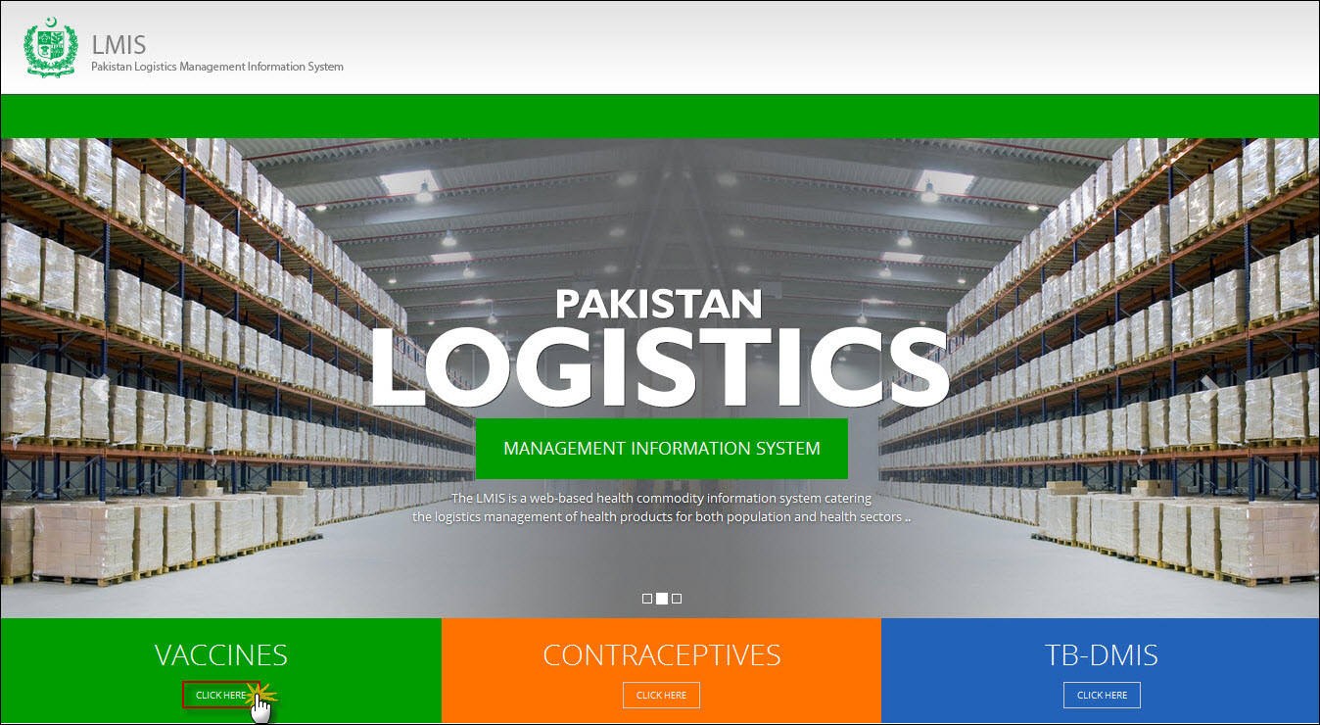**

Users can also access vaccine LMIS application directly by using <http://v.lmis.gov.pk> URL. Once the user enters the URL <http://v.lmis.gov.pk>, a user interface (homepage) will appear. The homepage displays a basic introduction to the ‘vaccine LMIS’.

|  |  |
| --- | --- |
| *C:\Users\isbah.zulfiqar\Desktop\1382615592_file_edit.png* | Before You Begin...  It is recommended to use vLMIS with Google or Mozilla Fire Fox. Older generations of browsers are also supported; however, their use can lead to issues with on-screen formatting and display. |

Once you click Vaccines, homepage for vLMIS will display.

## Homepage Menu

The available menu items can be found on the top of homepage screen. The components are displayed adjacently, as shown in the image below:

**C:\Users\Administrator\Desktop\vLMIS Screenshots\vaccine tab.jpg**

### Contact Us Tab

The Contact Us tab contains addresses, telephone numbers and email addresses (where available) for key personnel as a system communication list. Therefore, the user of LMIS will be able to see contact details of other stakeholders and can contact them as needed.

### Frequently Asked Questions Tab

The menu also contains a FAQ’s tab in order to provide guidance towards the most frequently asked and critical questions.

## Logging into Vaccine Logistics Management Information System

vLMIS is a web-based inventory and cold chain management application that makes it simple for beginners and experienced users to report inventory and cold chain data, view performance and graphical reports as well as maps.

|  |  |
| --- | --- |
| *C:\Users\isbah.zulfiqar\Desktop\1382615592_file_edit.png* | **Before You Begin...**  Make sure you have your correct log in credentials. When you register with vLMIS, the accounts and its related details along with the login domain details will be provided to you by the vLMIS Administrator. |

To Log in to vLMIS:

1. Go to <http://v.lmis.gov.pk>
2. Click the button **Click Here** on the Vaccines tab.

vLMIS login page will be displayed.  
**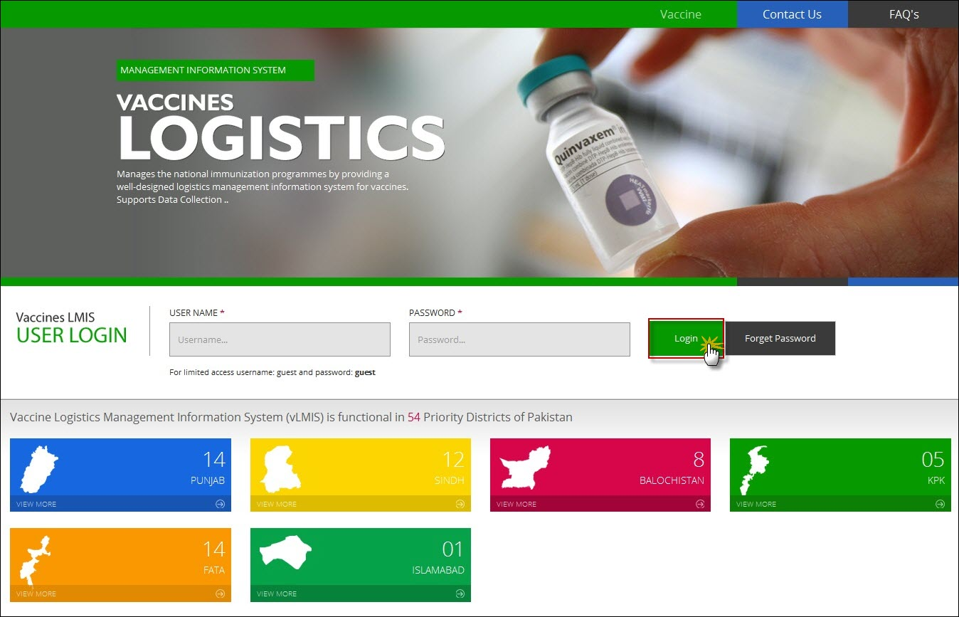**

1. Specify the **Username** and **Password** provided to you by the Administrator.

|  |  |
| --- | --- |
| *C:\Users\isbah.zulfiqar\Desktop\1382615592_file_edit.png* | To login as a guest or anonymous user, you can simply provide the following credentials:  **Username**: guest **Password**: guest |

|  |  |
| --- | --- |
|  | You can change the password provided to you by the administrator. See “*Changing Your Password*” for details.  Never give out your password to anyone for security purposes. |

1. Click **Login**.  
   The Vaccine Logistics Management Information System Dashboard Screen displays.

### Changing Your Password

To change your cLMIS password:

1. Login to cLMIS application.

The welcome screen displays.

1. On the right-side of the application, the user login name appears.
2. Under the login name, click Change Password as shown in the image below:

**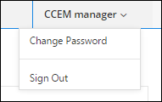**

1. Specify the following:

* **Old Password**: specify your old password.
* **New Password**: specify the new password.
* **Confirm New Password**: retype your password.

|  |  |
| --- | --- |
| *C:\Users\isbah.zulfiqar\Desktop\1382615592_file_edit.png* | Password Requirements  Your password must have a combination of a capital alphabet and one Numeric. |

|  |  |
| --- | --- |
|  | Never give out your password to anyone for security purposes. |

1. Click **Change Password**.  
   Your password will be changed successfully.

### Forgot Password

In case you have forgotten your password:

1. Open the vLMIS login page by entering the URL: <http://lmis.gov.pk>.
2. In the Login section, click **Forgot Password** as shown in the image below:  
     
   **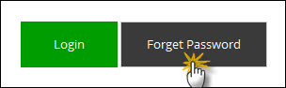**

You will be redirected to the Forgot Password Page.

1. In the Email entry box, enter your email address as validated in your account information by the Administrator.   
   An email will be sent on your email address for resetting your password.
2. Click the Reset Password link in the email to go to reset password page.
3. Specify the following:
   * **New Password**: specify the new password.
   * **Confirm New Password**: retype your password.

|  |  |
| --- | --- |
| *C:\Users\isbah.zulfiqar\Desktop\1382615592_file_edit.png* | Password Requirements  Your password must have a combination of a capital alphabet and one Numeric. |

|  |  |
| --- | --- |
|  | Never give out your password to anyone for security purposes. |

1. Click **Change Password**.  
   Your password will be changed successfully.

### Logging Out

When signed in, click **Sign out** on the right-side of the application, as shown in the image below:  
  
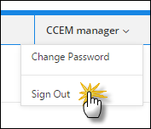

# CCEM Administrator

A vaccine’s cold chain is a [temperature](http://en.wikipedia.org/wiki/Temperature)-controlled [supply chain](http://en.wikipedia.org/wiki/Supply_chain). It is essential for the effectiveness of the vaccines that an unbroken cold chain with uninterrupted series of storage and distribution activities are maintained for the given temperature range.

Once you log into the vLMIS as a CCEM administrator, the following screen will be displayed by default:

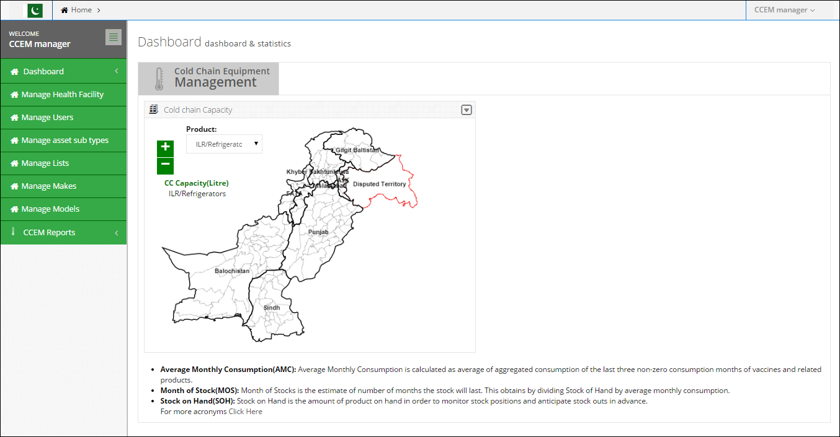

On the left-side of the screen, you can view the main-menu as shown below:

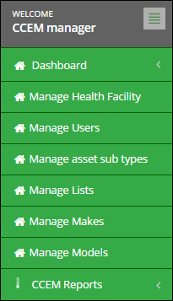

## Manage Health Facility

Manage health facility tab in CCEM admin can be used to manage the health facilities in the UCs. Through the manage health facility screen, admin can search, add as well as edit health facilities.

The mentioned screens are given below:

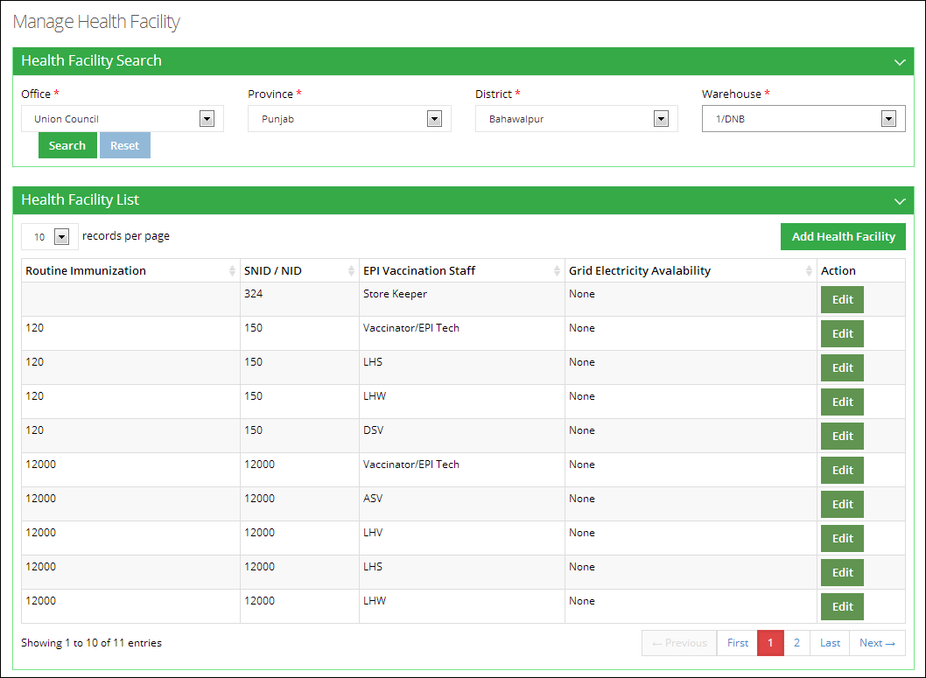

### Add Health Facility

To add a health facility:

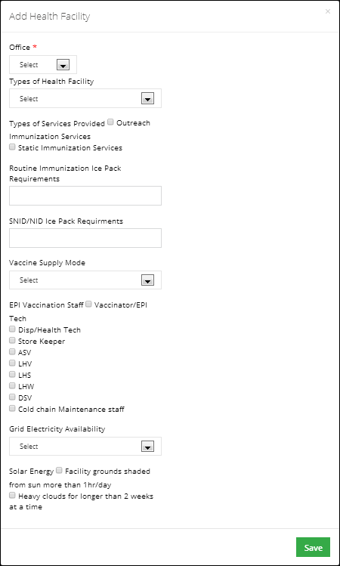

### Edit Health Facility

To edit a health facility:

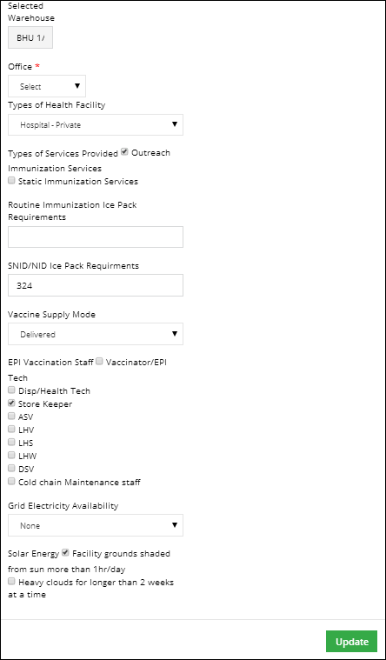

## 

## Manage Users

Manage users tab in CCEM admin can be used to manage the CCEM users at all levels. Through the manage users screen, admin can search a user based on user role, add, edit as well as delete a user role.

The mentioned screens are given below:

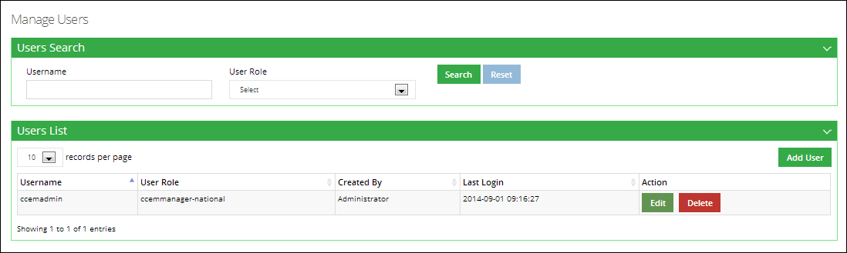

### Add User

To add a user:

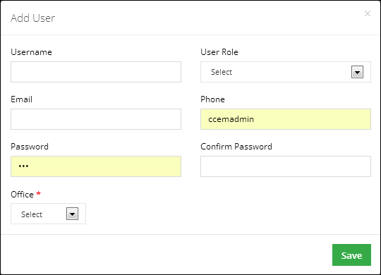

## Manage Lists

Manage lists tab in CCEM admin can be used to manage the lists available to the CCEM managers. Through the manage lists screen, admin can search a list based on list value, add, edit as well as delete these list values.

The mentioned screens are given below:

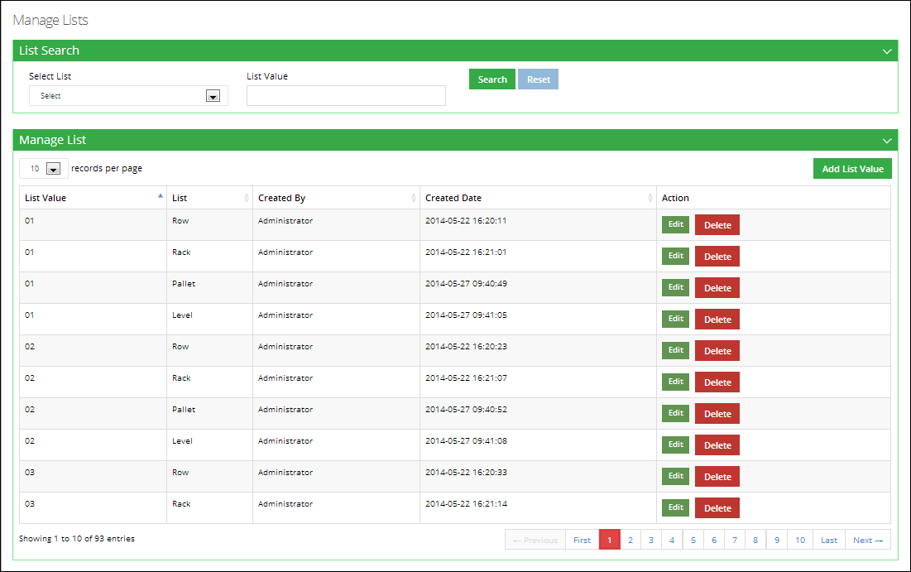

### Add List Value

To add a list value:

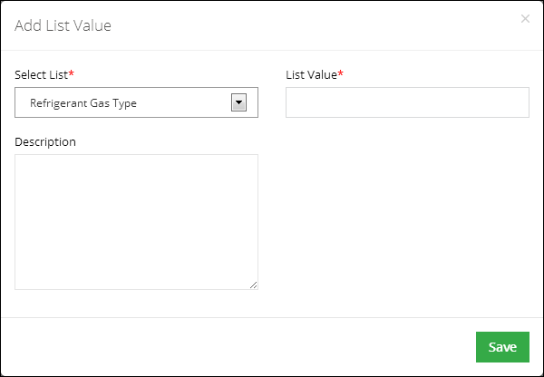

### Edit List Value

To edit a list value:

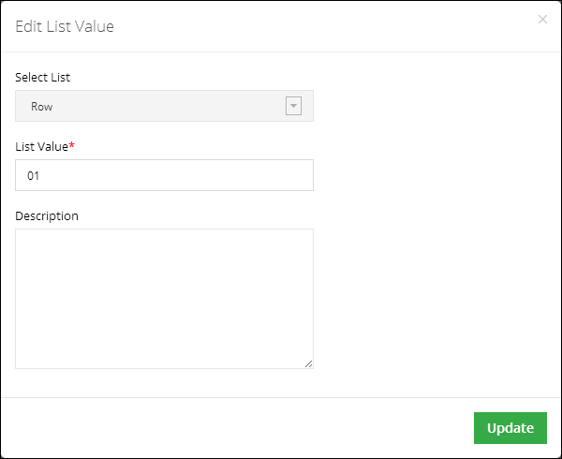

## Manage Asset Sub-types

Manage asset sub-types tab in CCEM admin can be used to manage the asset sub-types available to the CCEM managers. Through the manage asset sub-type screen, admin can search an asset sub-type, add, edit as well as activate or deactivate these sub-types.

The mentioned screens are given below:

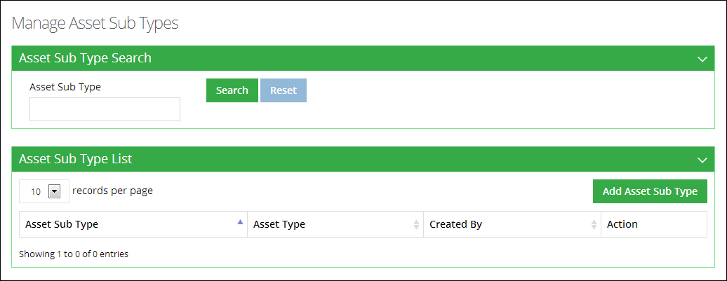

### Add Asset Sub-type

To add asset sub-type:

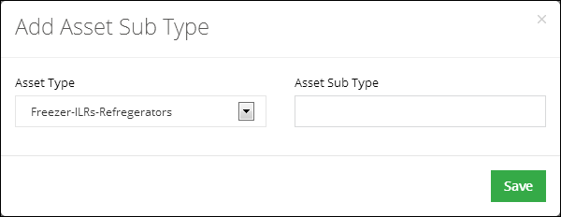

### Edit Asset Sub-type

To edit asset sub-type:

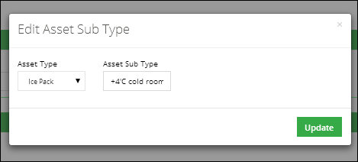

## Manage Makes

Manage makes tab in CCEM admin can be used to manage the make of the added assets available to the CCEM managers. Through the manage makes screen, admin can search a make based on its status, add, edit as well as delete these makes.

The mentioned screens are given below:

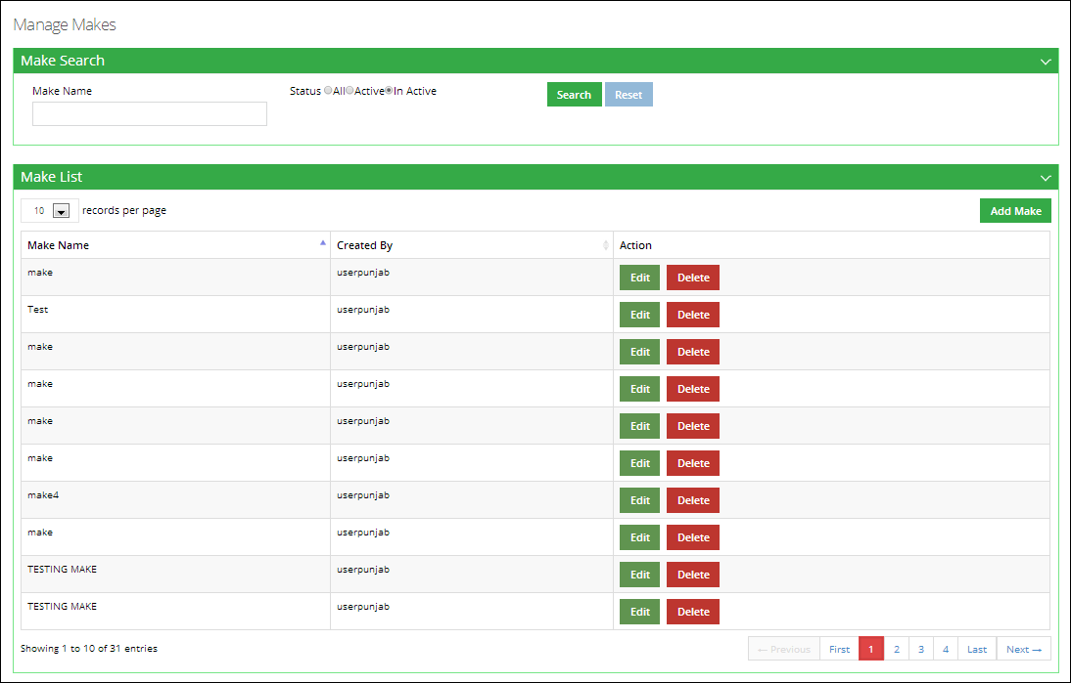

### Add Make

To add a make of the asset:

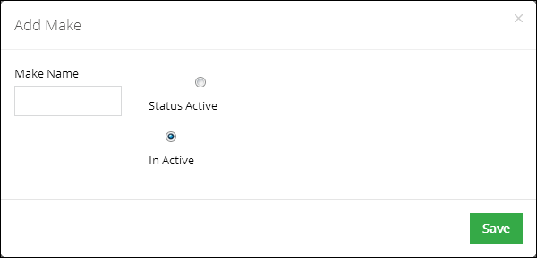

### Edit Make

To edit a make of the asset:

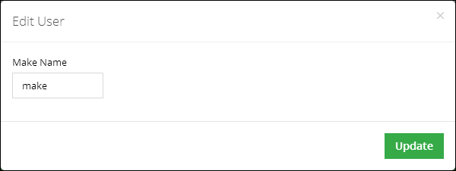

## Manage Models

Manage models tab in CCEM admin can be used to manage the model of the assets available to the CCEM managers. Through the manage models screen, admin can search a model based on Model Name, Catalogue ID, its Status, Asset Type and Make. CCEM admin can also add or edit a model in the list. He / She can also activate or deactivate a model of the asset.

The mentioned screens are given below:

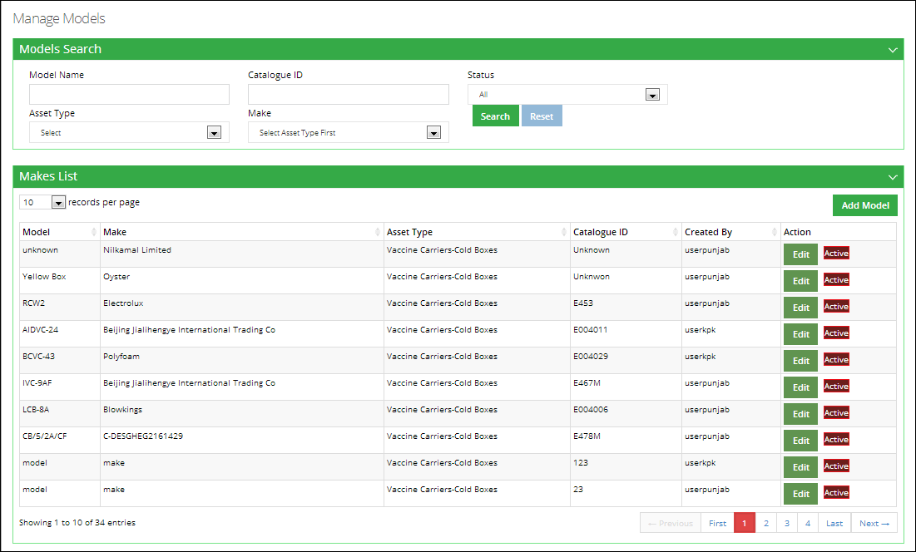

### Add Model

To add a model of the asset:

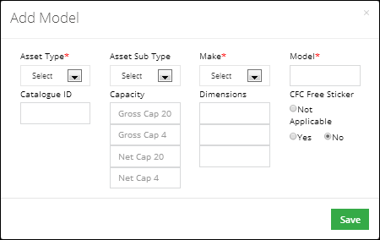

### Edit Model

To edit a model of the asset:

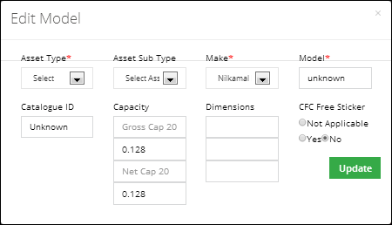

|  |  |
| --- | --- |
| Super Administrator | **4** |
| Process to using Vaccines Logistics Management  Information System | |

This section explains the step-by-step instructions on getting started with vLMIS as a cold-chain equipment management (CCEM) administrative.

# Super Administrator

A super administrator can manage authenticated users and their roles within the vLMIS. This administrator can also manage stakeholder from here.

Once you log into the vLMIS as a super administrator, the following screen will be displayed by default:

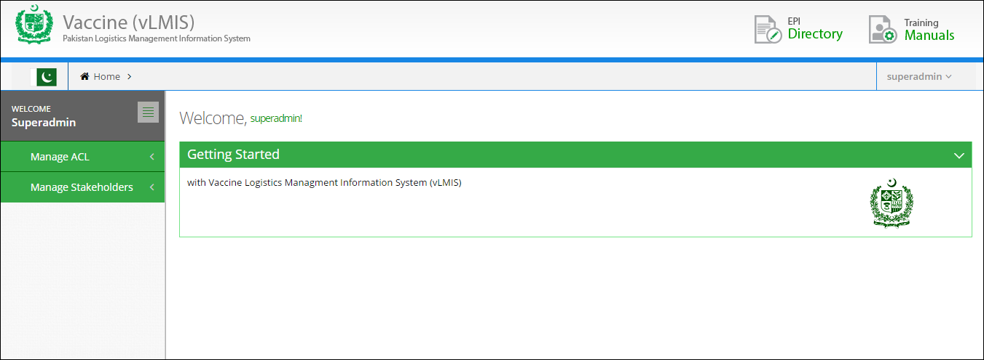

On the left-side of the screen, you can view the main-menu as shown below:

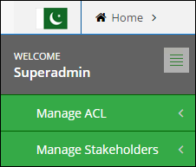

## Manage ACL

Super administrator can use this tab to manage authenticated users and their assigned roles. Any resources associated with these roles can also be managed here.

Click Manage ACL tab to view the sub-menu items as shown below:

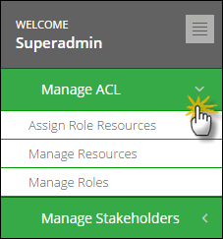

### Assign Role Resources

The Assign Role Resources tab admin can be used to manage roles and their resources. These roles and resources are user-level specific. Through the manage role resources screen, admin can search, assign various resources to the roles and delete the undesired entries.

The mentioned screens are given below:

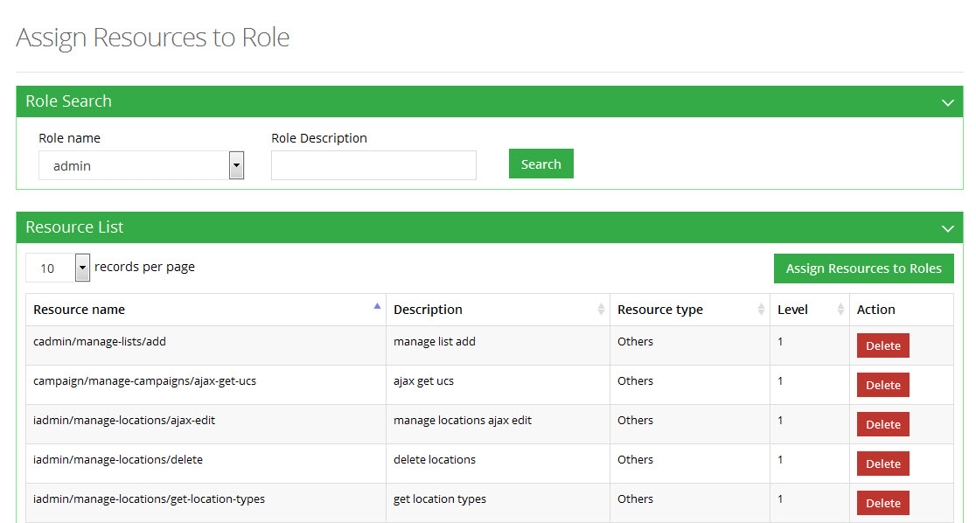

**Add Resource**

To add a resource:

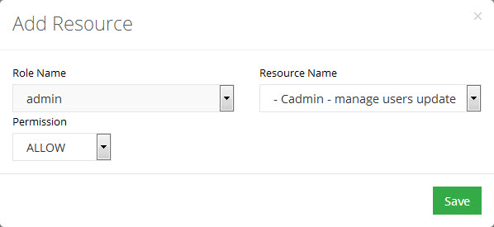

### Manage Resources

With the help of Manage Resources tab, the admin can manage system resources, which is visible to different user levels. Admin can search, add, edit and delete resources through manage resources screen.

The mentioned screens are given below:

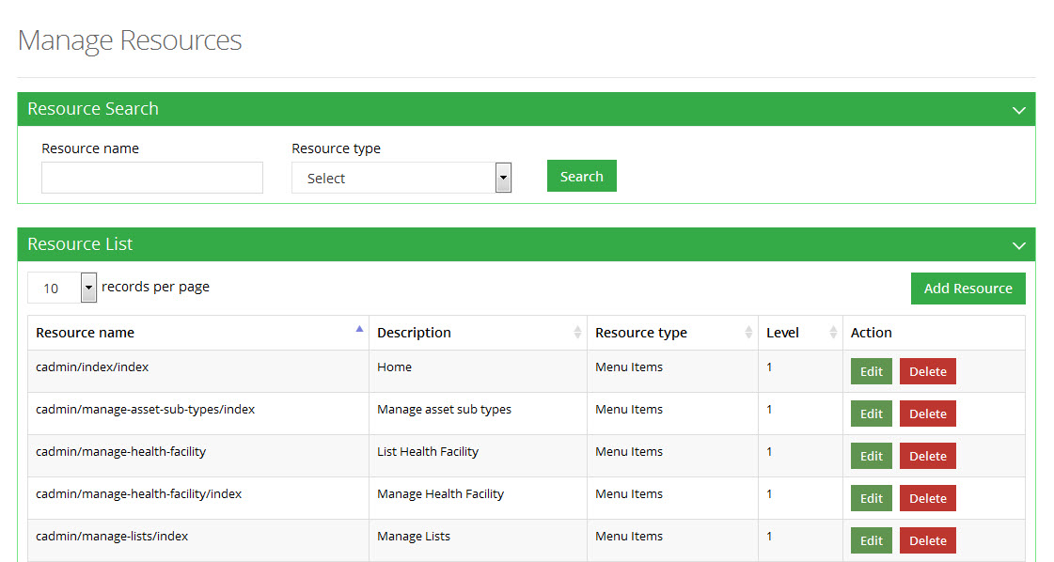

**Add Resource**

To add a resource:

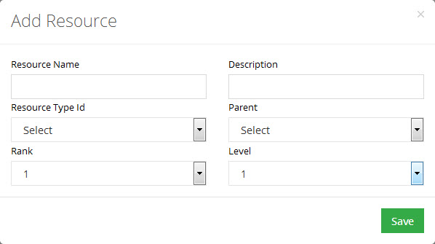

**Edit Resource**

To edit a resource:

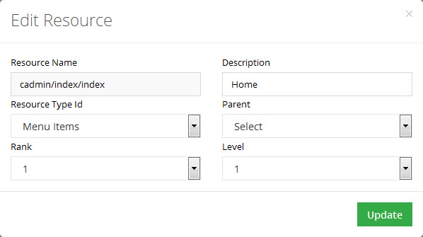

### Manage Roles

With the help of Manage Roles tab admin can manage system roles, which is visible to different user levels. Admin can search, add, edit and delete roles through manage roles screen.

The mentioned screens are given below:

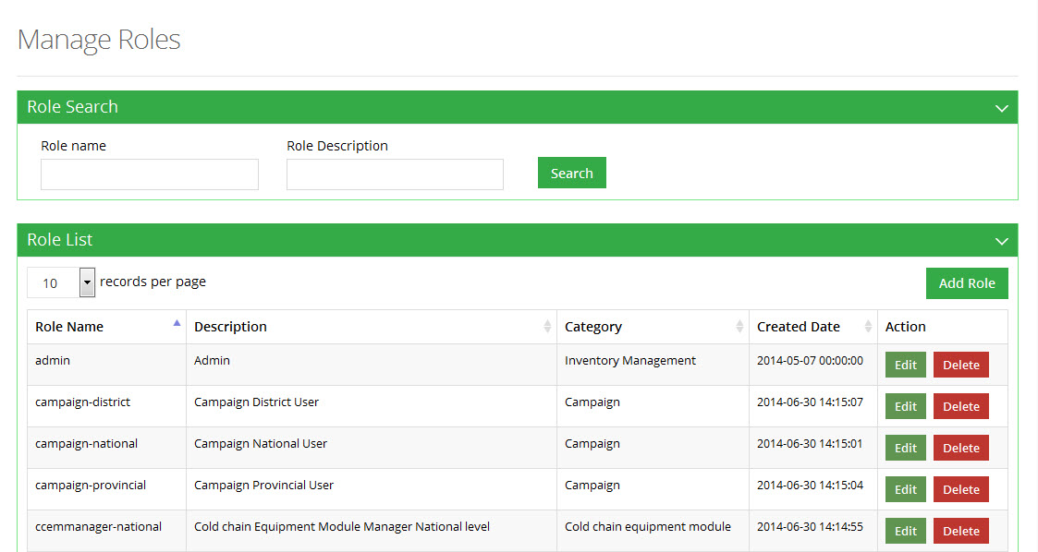

**Add Role**

To add a role:

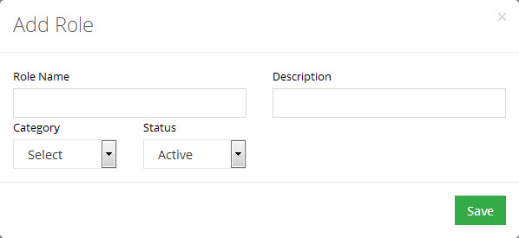

**Edit Role**

To edit a role:

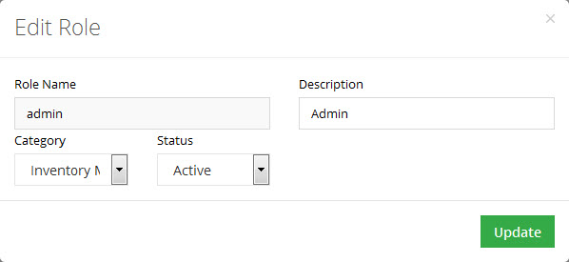

## Manage Stakeholders

With the help of Stakeholders tab admin can manage system stakeholders, which is visible to different user levels.

### Stakeholders

Admin can search, add and edit product through manage stakeholders screen.

The mentioned screens are given below.

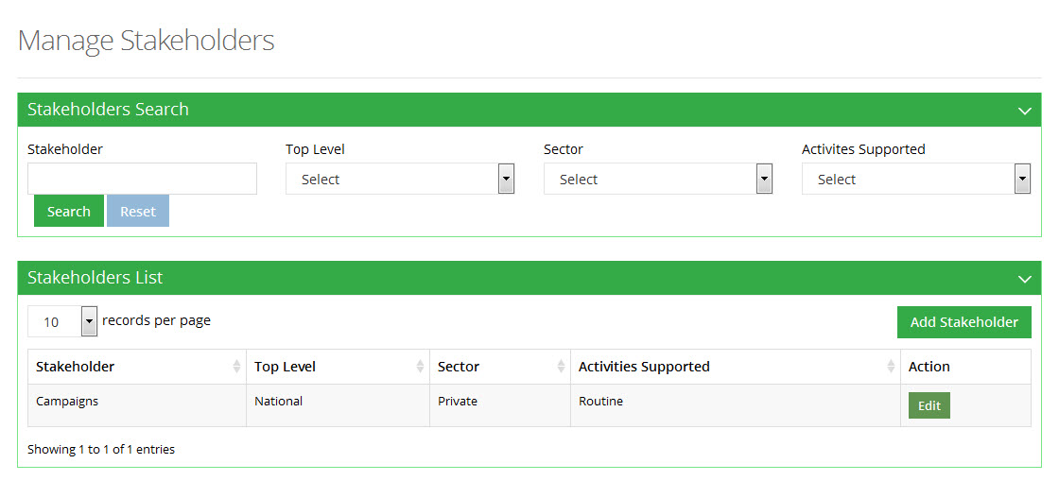

**Add Stakeholder**

To add a stakeholder:

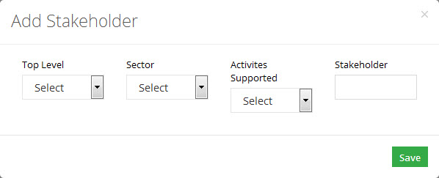

**Edit Stakeholder**

To edit a stakeholder:

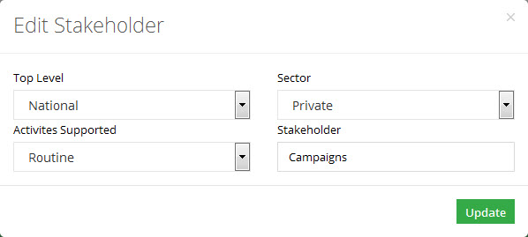

|  |  |
| --- | --- |
| General Administrator | **5** |
| in Vaccine Logistics Management Information System | |

This section explains the step-by-step instructions on the general admin that can be used by the Vaccine Logistics Management Information system’s administrator.

# Administrator

The vLMIS administrator (admin) can manage and administer all control data which includes managing products, stakeholders, locations, stores / facilities as well as users.

## Manage Products

With the help of Products tab admin can manage system products, which is visible to different user levels.

### Products

Admin can search, add and edit product through manage product screen.

The mentioned screens are given below:

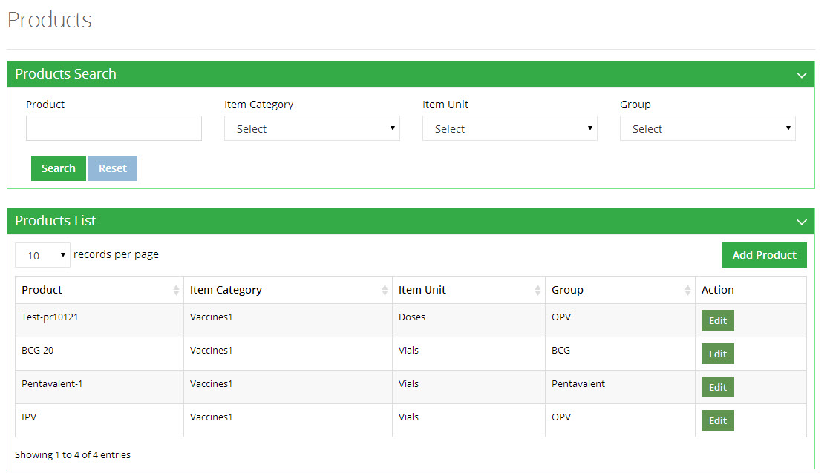

**Add Product**

To add a product:

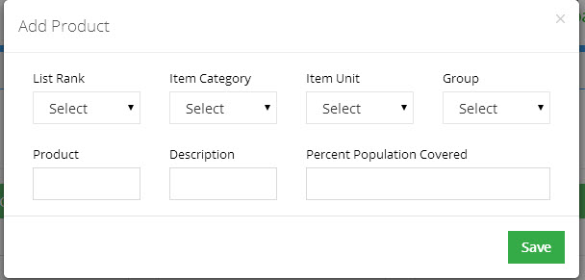

**Edit Product**

To edit a product:

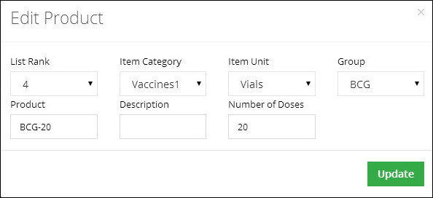

### Setup Barcode

With the help of Setup Barcode tab admin can manage system barcode setting up, which is visible to different user levels. Admin can search, add, edit, detail, delete product through manage setup barcode screen.

The mentioned screens are given below:

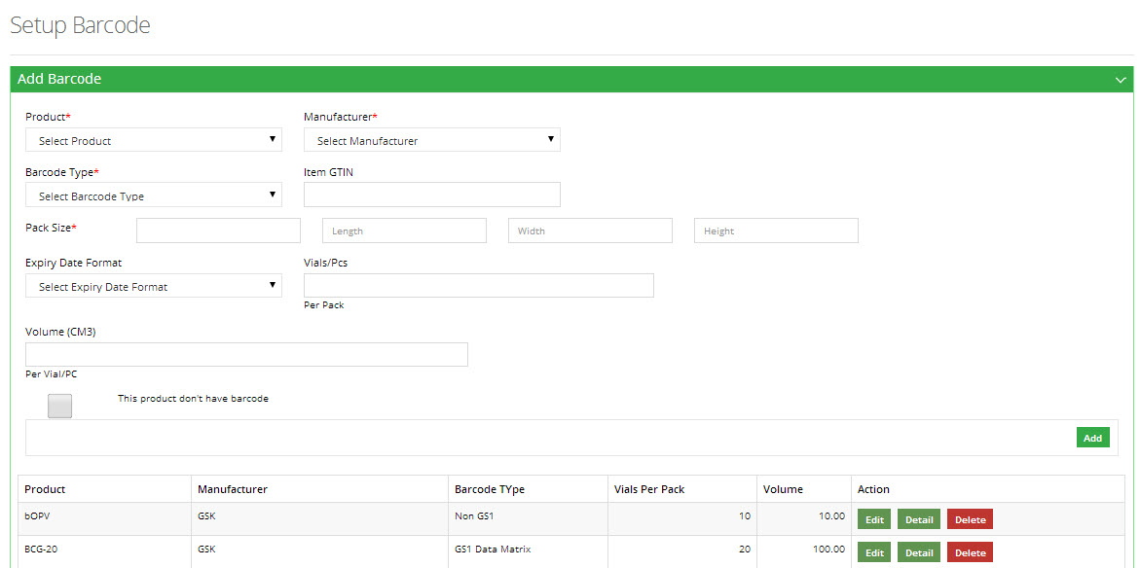

**Update Barcode**

To update a barcode:

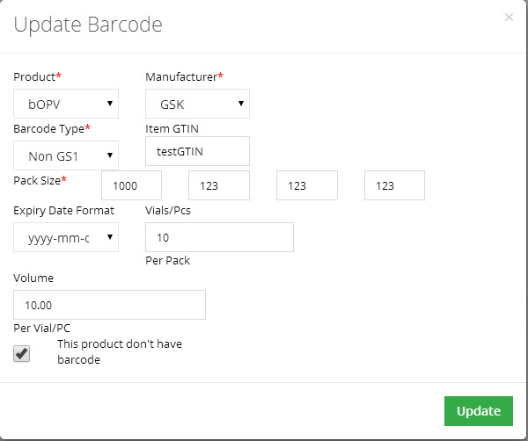

**Add Product Barcode Detail**

To add barcode detail of a product:

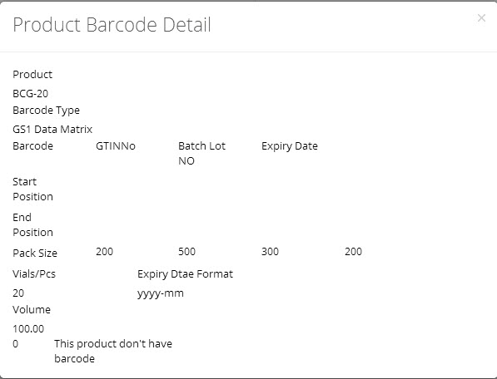

### Item Categories

With the help of Item Categories tab admin can manage system item categories e.g. vaccines and non-vaccines. Admin can search, add, edit, delete item categories through manage item categories screen.

The mentioned screens are given below:

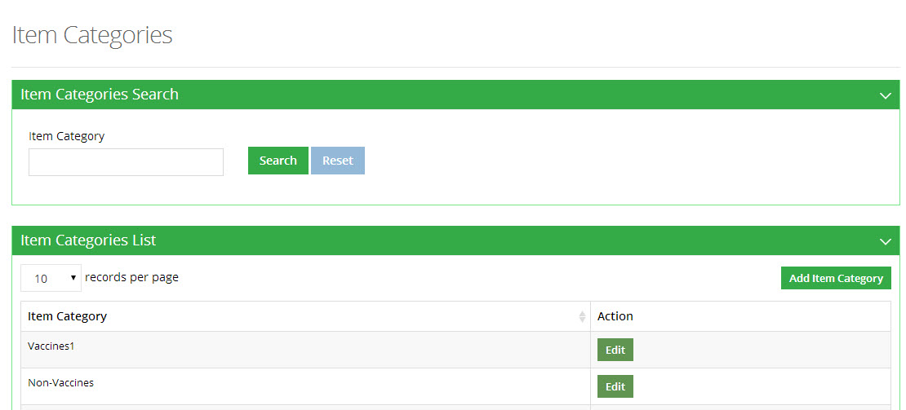

**Add Item Category**

To add an item category:

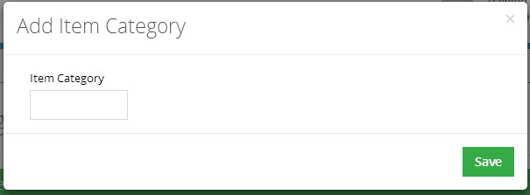

**Edit Item Category**

To edit an item category:

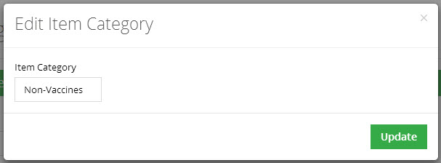

### VVM Types

With the help of VVM types tab, administrator can manage VVM types which are visible to different user i.e. Stage 1, Stage 2, Stage 3 and Stage 4.

The mentioned screens are given below:

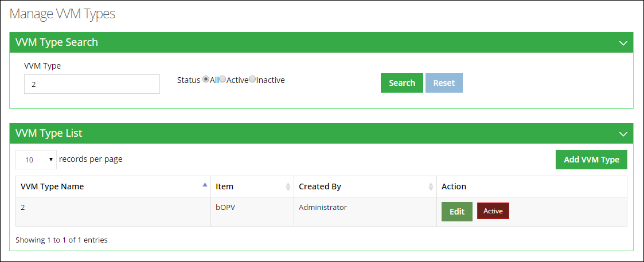

**Add VVM Type**

To add a VVM Type:

**Edit Item Category**

To edit an item category:



### Transaction Types

With the help of Transaction Types tab, admin can manage system transaction types which are visible to different users. The nature of the transaction types can either be positive or negative. Admin can add or edit a transaction type by using this screen.

The mentioned screens are given below:

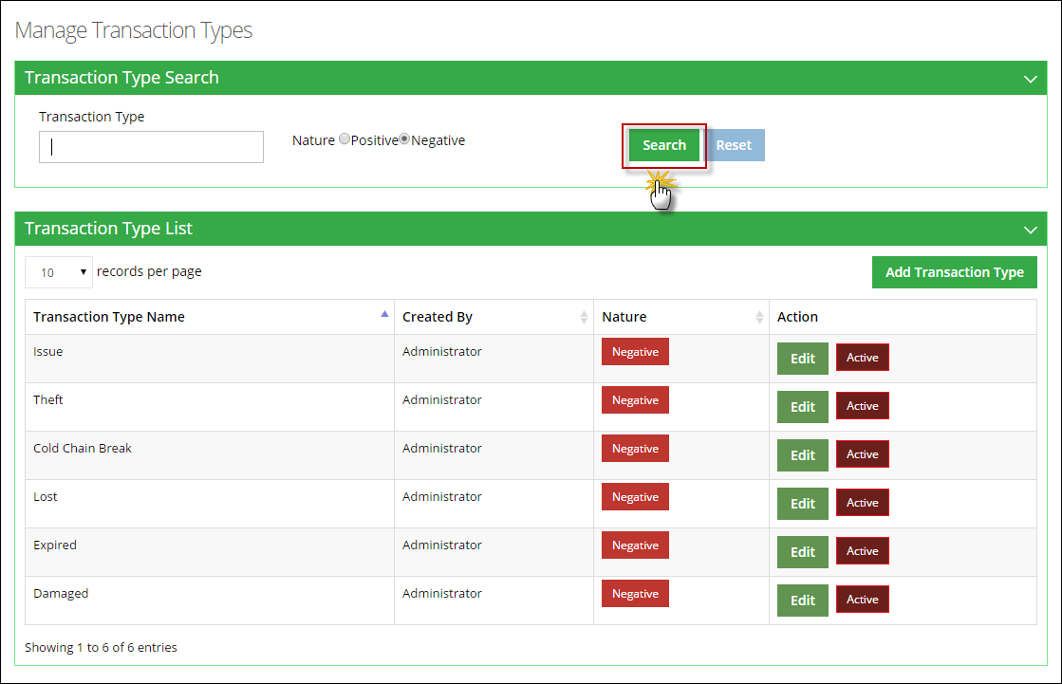

**Add Transaction Type**

To add a Transaction Type:

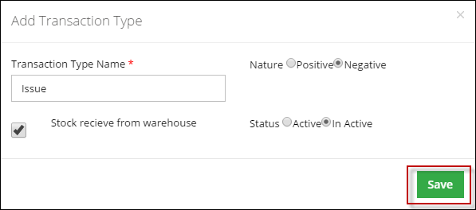

**Edit Transaction Type**

To edit a transaction Type:

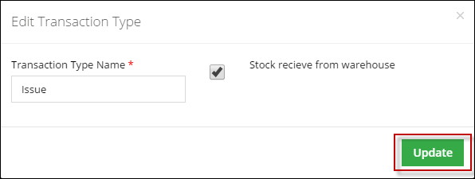

### Item Units

With the help of Item Units tab, admin can manage system item units, which are visible to different user levels. Admin can search, add and edit product through manage item units screen.

The mentioned screens are given below:

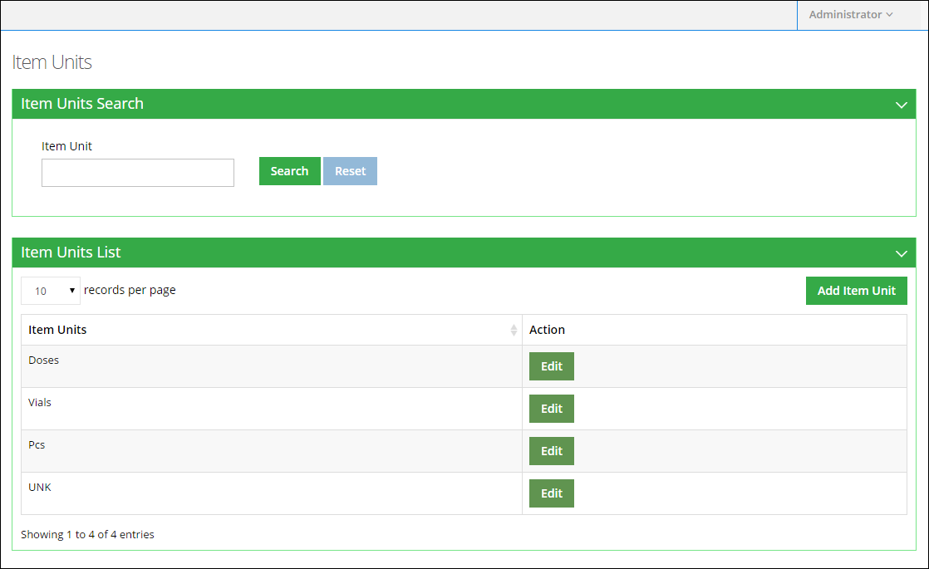

**Add Item Unit**

To add an item unit:

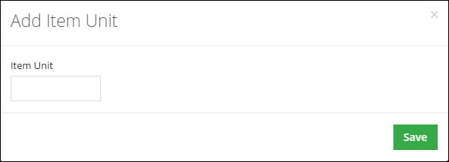

**Edit Item Unit**

To edit an item unit:

### Item Groups

With the help of Item Groups tab admin can manage system item groups, which is visible to different user levels. Admin can search, add and edit product through manage item groups screen.

The mentioned screens are given below:

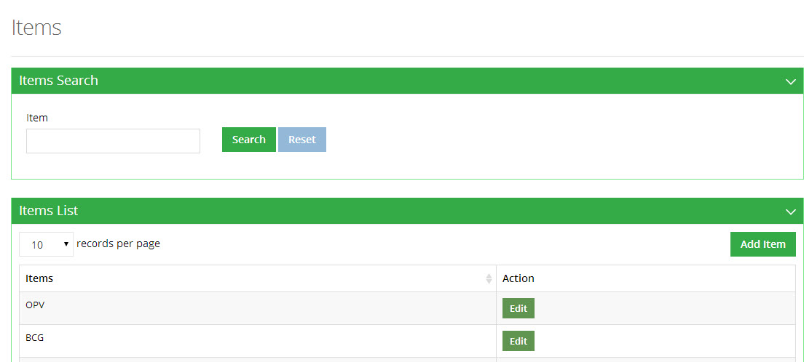

**Add Item**

To add an item:

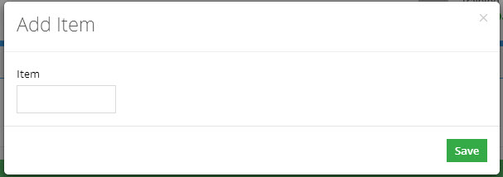

**Edit Item**

To edit an item:

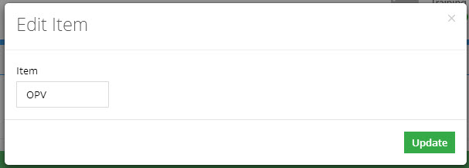

## Manage Stakeholders

### Stakeholders

With the help of Stakeholders tab admin can manage system stakeholders, which is visible to different user levels. Admin can search, add and edit product through manage stakeholders screen.

The mentioned screens are given below.



**Add Stakeholder**

To add a stakeholder:



**Edit Stakeholder**

To edit a stakeholder:



### Office

With the help of Office tab admin can manage system offices, which is visible to different user levels. Admin can search, add and edit office through manage product screen.

The mentioned screens are given below.

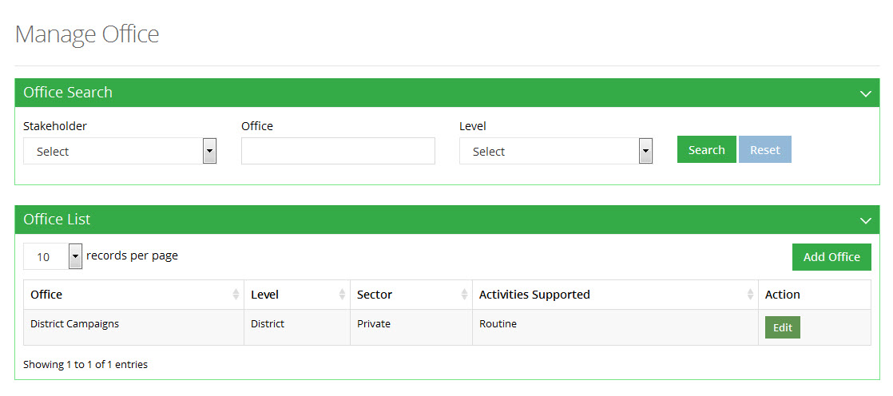

**Add Office**

To add an office:

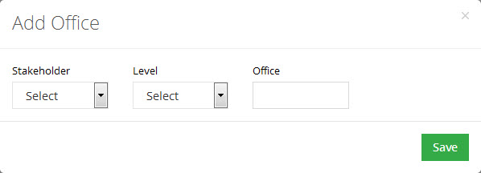

**Edit Office**

To edit an office:

**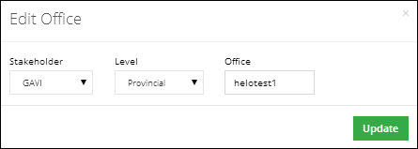**

### Manufacturer

With the help of Manufacturer tab admin can manage system manufacturer, which is visible to different user levels. Admin can search, add and edit manufacturer through manage manufacturer screen.

The mentioned screens are given below:

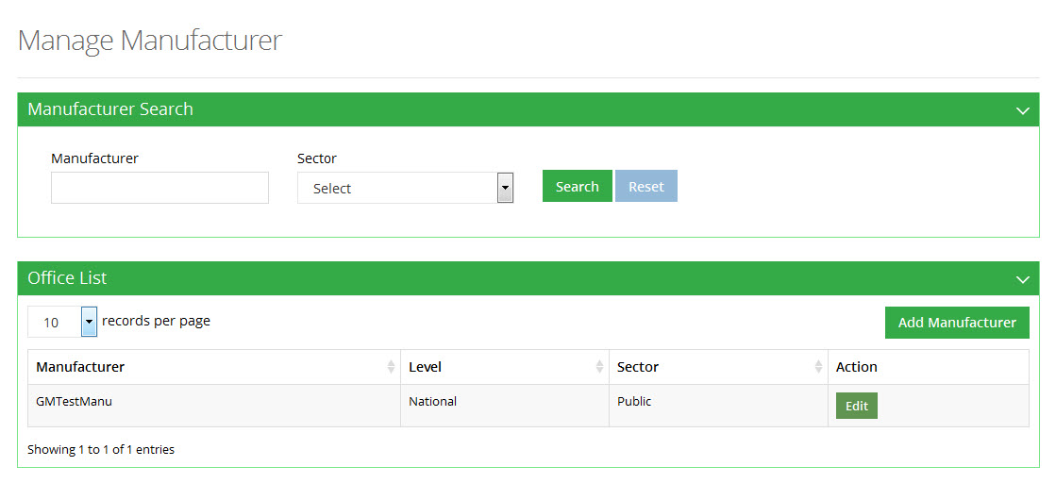

**Add Manufacturer**

To add a manufacturer:

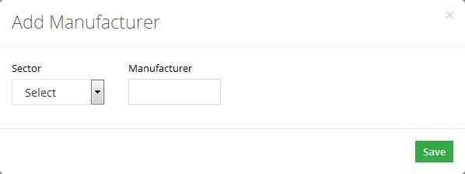

**Edit Manufacturer**

To edit a manufacturer:

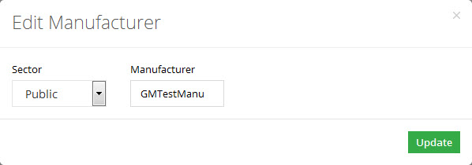

### Stakeholder Activities

With the help of Stakeholder Activities tab admin can manage system stakeholder activities, which are visible to different user levels. Admin can search, add and edit product through manage stakeholder activities screen.

The mentioned screens are given below:

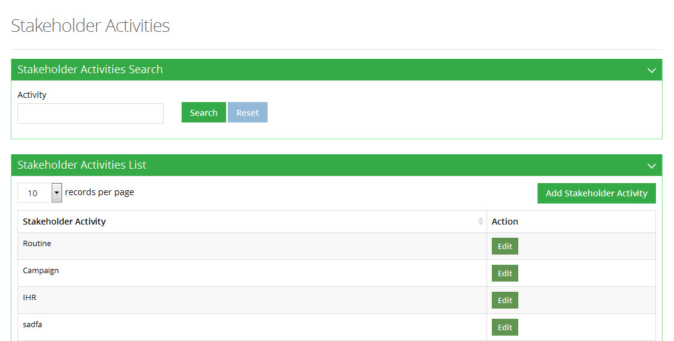

**Add Stakeholder Activity**

To add a stakeholder activity:

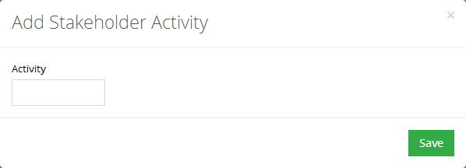

**Edit Stakeholder Activity**

To edit stakeholder activity:

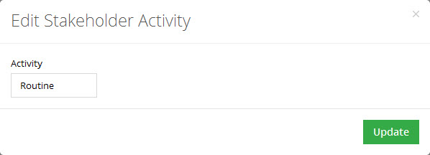

### Stakeholder Types

With the help of Stakeholder Types tab admin can manage system stakeholder types, which are visible to different user levels. Admin can search, add and edit stakeholder types through manage stakeholder types screen.

The mentioned screens are given below:

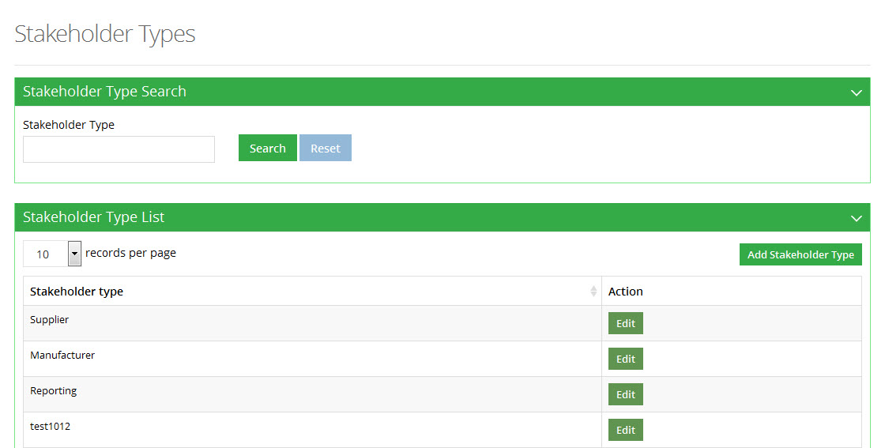

**Add Stakeholder Type**

To add a stakeholder type:

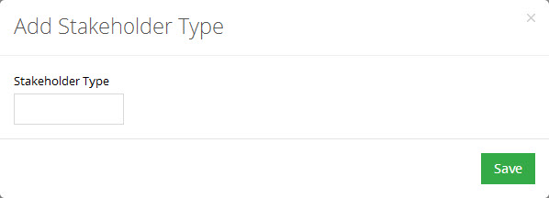

**Edit Stakeholder Type**

To edit a stakeholder type:

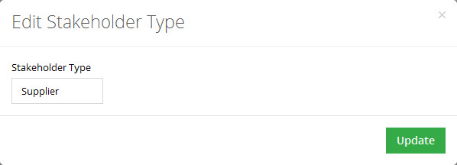

### Stakeholder Sectors

With the help of Stakeholder Sectors tab admin can manage system stakeholder sectors, which are visible to different user levels. Admin can search, add and edit stakeholder sectors through manage stakeholder sectors screen.

The mentioned screens are given below:

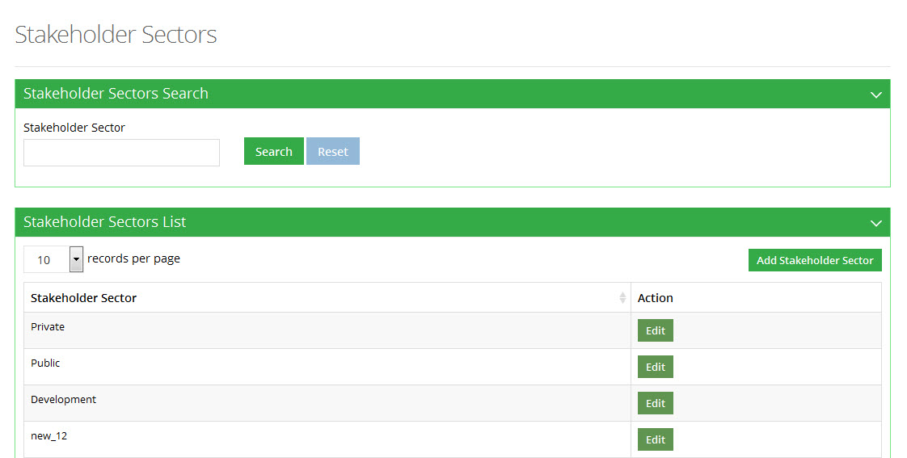

**Add Stakeholder Sector**

To add a stakeholder sector:

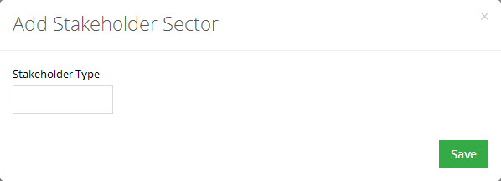

**Edit Stakeholder Sector**

To edit a stakeholder sector:

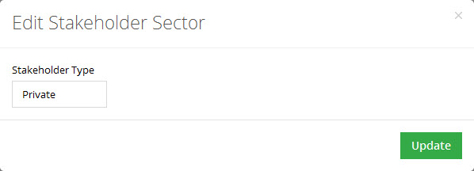

### Stakeholder Items

With the help of Stakeholder Items tab admin can manage system stakeholder items, which are visible to different user levels. Admin can search, add, edit, delete stakeholder items through manage stakeholder items screen.

The mentioned screens are given below:

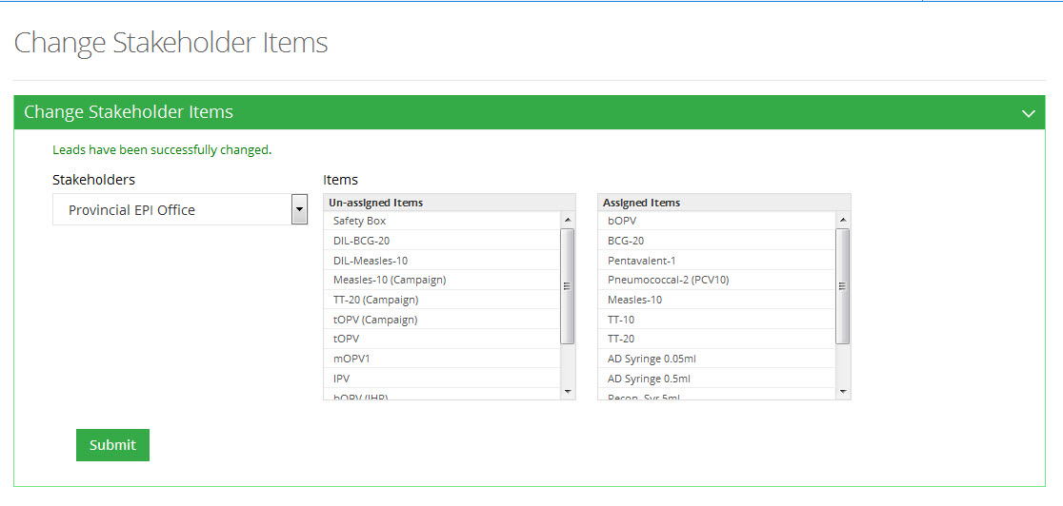

## Manage Locations

With the help of Manage Locations tab admin can manage system locations, which are visible to different user levels.

### Location Types

Admin can search, add as well as edit a location type using this screen.

The mentioned screens are given below:

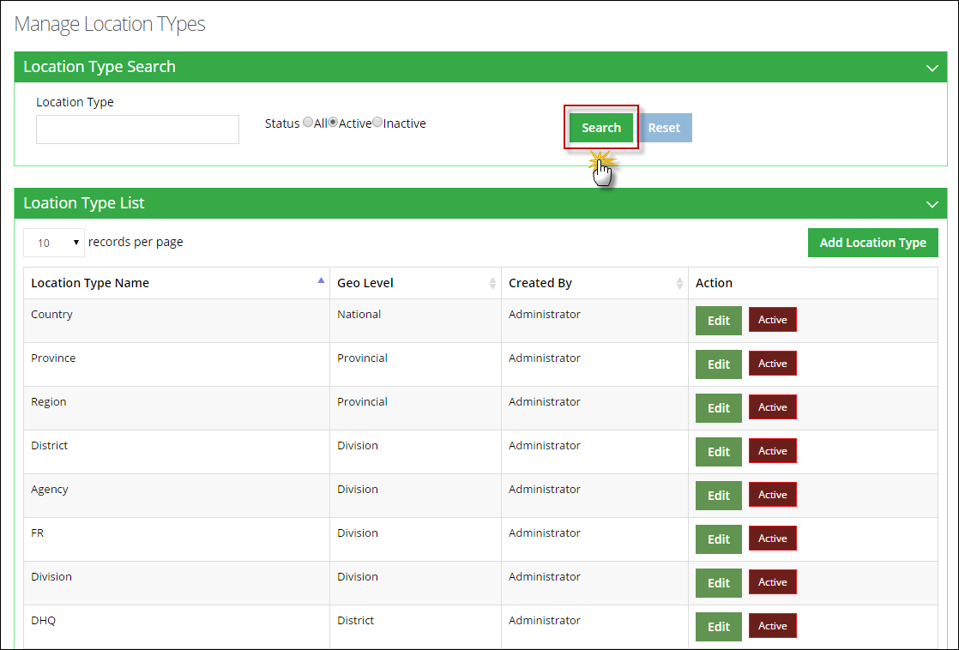

**Add Location Type**

To add a location type:

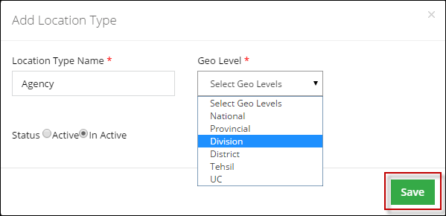

**Edit Location Type**

To edit a location type:

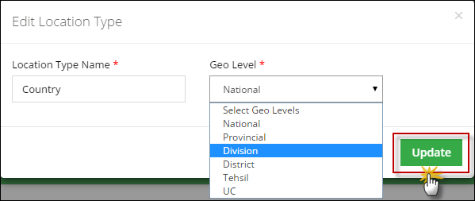

### Add Locations

Admin can search, add as well as edit a location using this screen.

The mentioned screens are given below:

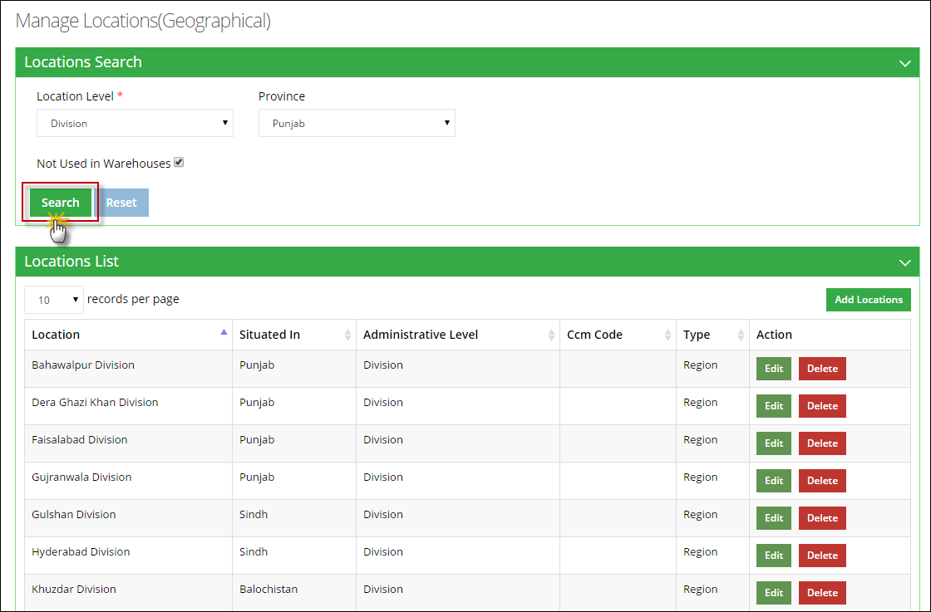

**Add Locations**

To add a location:

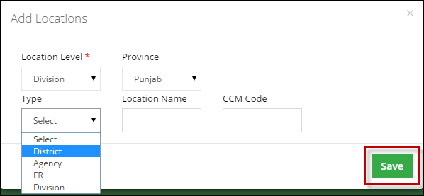

**Edit Location Type**

To edit a location type:

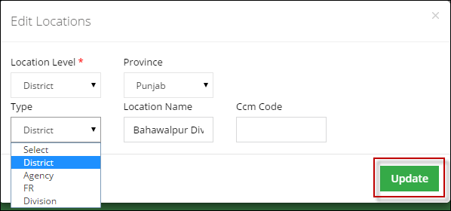

## Manage Stores/Facilities

With the help of Manage Stores/Facilities tab, admin can manage stores or health facilities within the system which can visible to different user levels.

### Routine

With the help of Routine tab admin can manage system routine, which is visible to different user levels. Admin can search, add, edit, delete routine through manage routine screen.

The mentioned screens are given below.

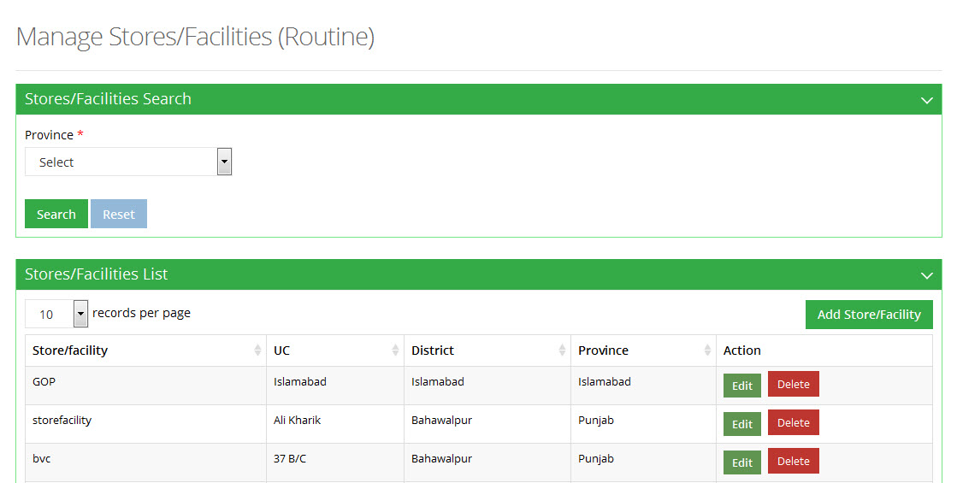

**Add Stores/Facilities**

To add stores/facilities:

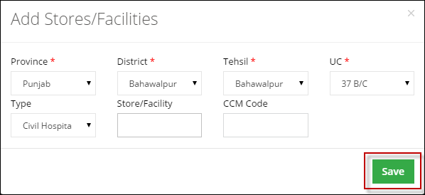

**Edit Stores/Facilities**

To edit stores/facilities:

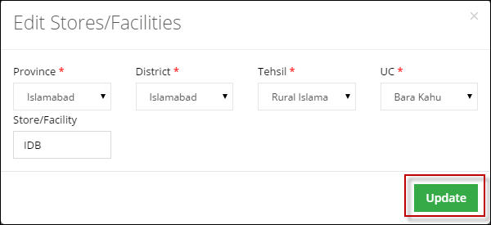

### Campaigns Teams

With the help of Campaign Teams tab admin can manage system campaign teams, which is visible to different user levels. Admin can search, add, edit, delete campaign teams through manage campaign teams screen.

The mentioned screens are given below.

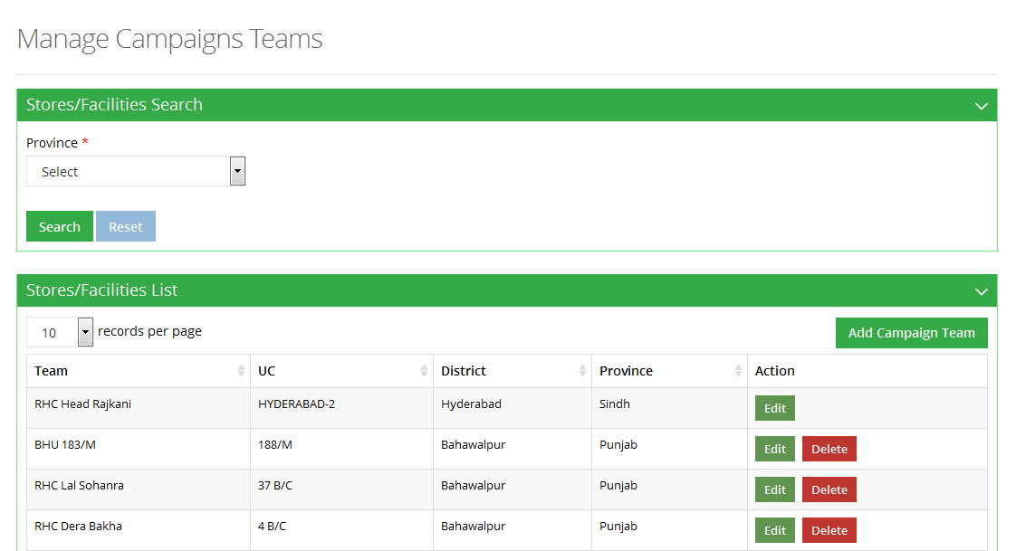

**Add Campaign Team**

To add a campaign team:

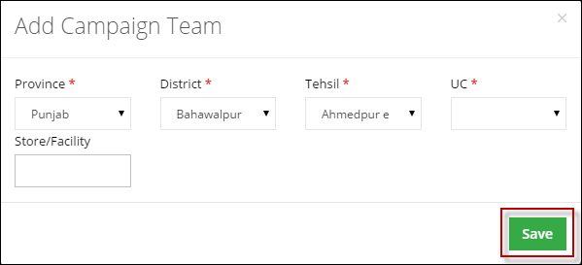

**Edit Stores/Facilities**

To edit stores / facilities:



### Inventory

With the help of Inventory tab admin can manage system inventory, which is visible to different user levels. Admin can search, add and edit inventory through manage inventory screen.

The mentioned screens are given below.

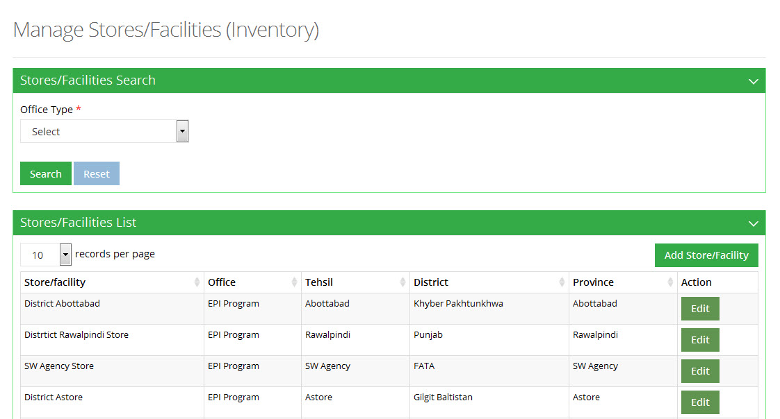

**Add Stores/Facilities**

To add stores / facilities:

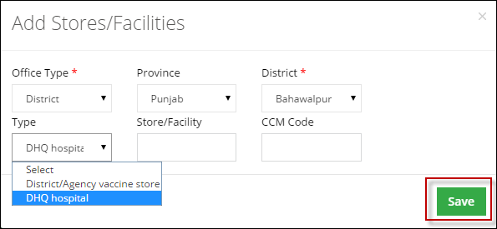

**Edit Stores/Facilities**

To edit stores / facilities:



## Manage Users

Admin can manage system users which are visible to different user levels.

### Routine Immunization

With the help of Routine Immunization Users tab, admin can manage system routine immunization users, which are visible to different user levels.

**Users**

Admin can search, add and edit these users through manage users screen.

**Update Cluster Leads**

To update cluster leads:

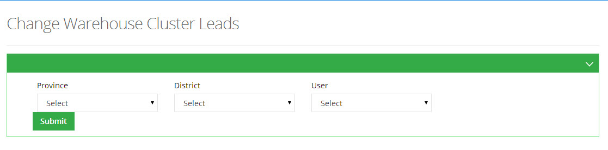

### Campaign Users

With the help of Campaign Users tab, administrator can manage system campaign users, which are visible to different user levels. Admin can search, add and edit campaign users through manage campaign users screen.

The mentioned screens are given below:

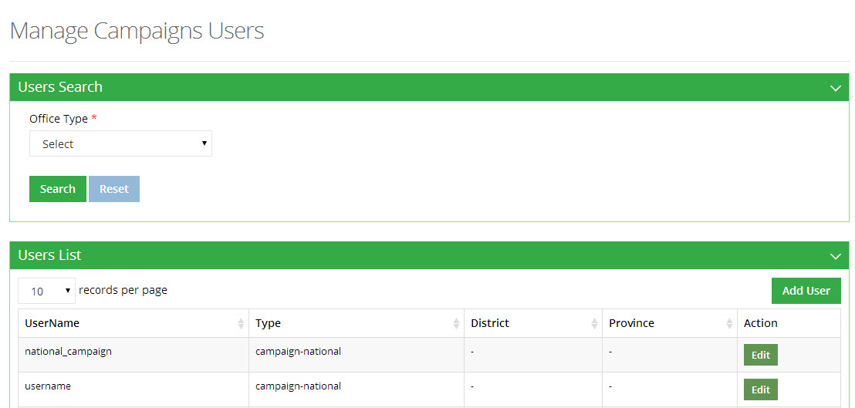

**Add User**

To add a user:

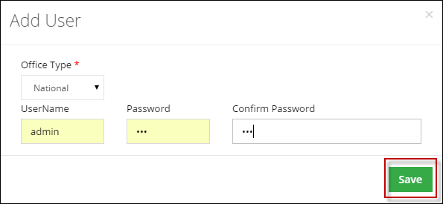

**Edit User**

To edit a user:

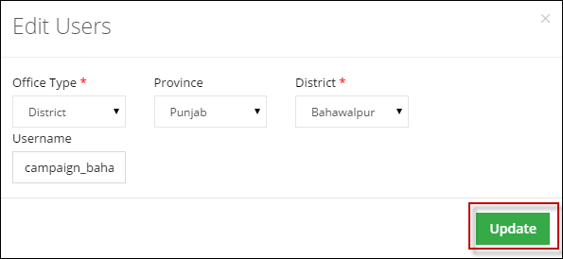

### IM Users

With the help of Inventory Users tab admin can manage system inventory users, which are visible to different user levels. Admin can search, add and edit inventory users through manage inventory users screen.

The mentioned screens are given below:

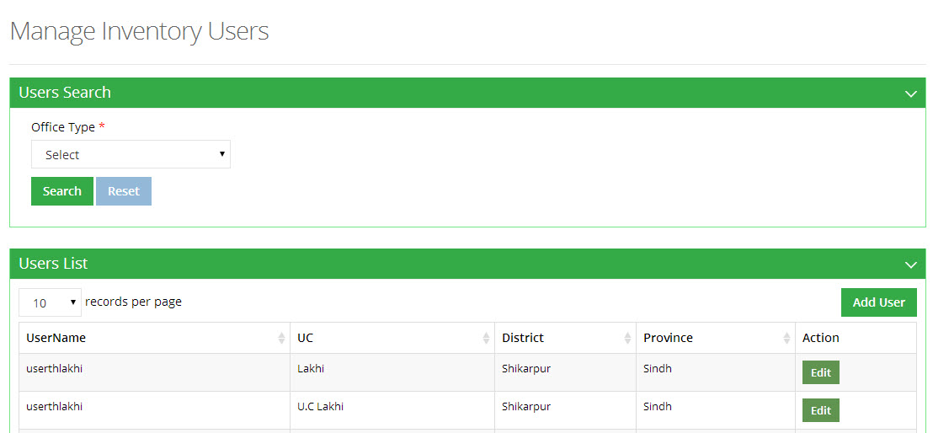

**Add User**

To add a user:

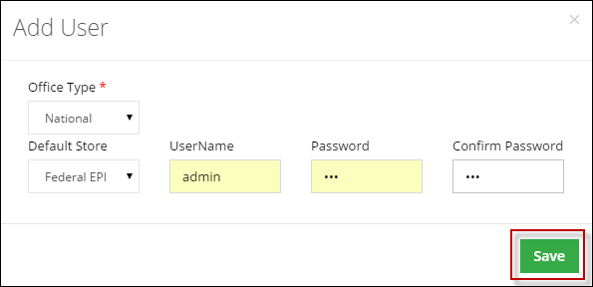

**Edit Users**

To edit users:

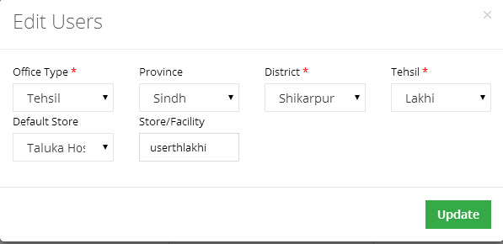

### Policy Users

With the help of Policy Users tab admin can manage system policy users, which can visible to different user levels. Admin can search, add and edit policy users through manage policy users screen.

The mentioned screens are given below:

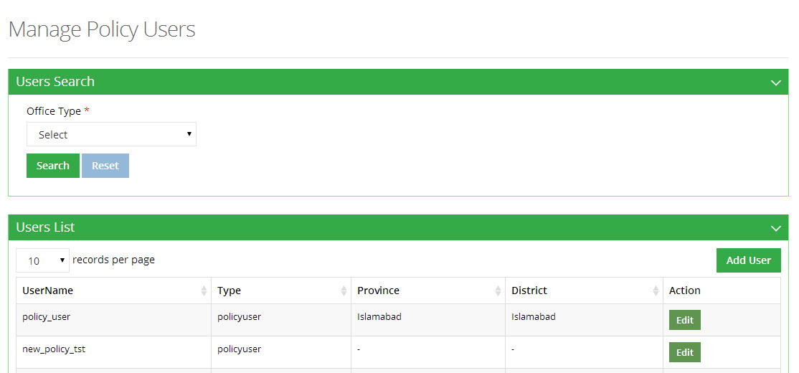

**Add User**

To add a user:

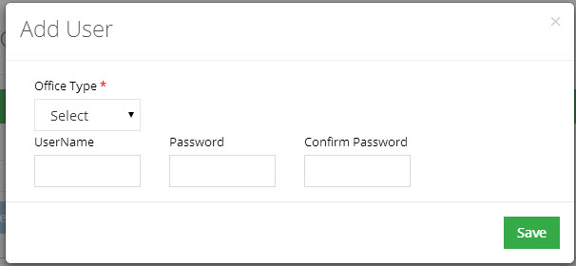

**Edit Users**

To edit users:

